JavaScript Screenshot plugin Documentation

## About/Value

The Screenshot.js API is a system that with the integration of the JavaScript Files and 3 lines of code a website can have a quick and simple way to give the users the options to take screenshots. While users can use their shortcuts to produce the same this API has strength in other areas.

### Simple

This API is quick to integrate and works on most websites. It just requires a few lines and a small JavaScript file. This file can also be modified to make them feedback requests with text sent to a server but for the point of this initial implementation it only does a screenshot

### Isolated Instances

By using the API we can make sure that the client only send a screenshot of the website they are browsing, not all their desktop or all their windows. For those interested in security and not wanting to have extra data and instances it is useful.

### Privacy Aware

People want to protect their information and data with their screen shots. By using this API the user has the option to black out any section of sensitive information before taking the photo

### Information specific

Most of Cisco's pages have large amounts of information and finding an error or issue can be like finding a needle in the haystack. Using these API users can identify the sections they want to bring attention to in order to make the issue finding quicker.

## Usage User Side

I have assembled a few screenshots of a basic website to demonstrate how a user would go about interacting with the screenshot item.

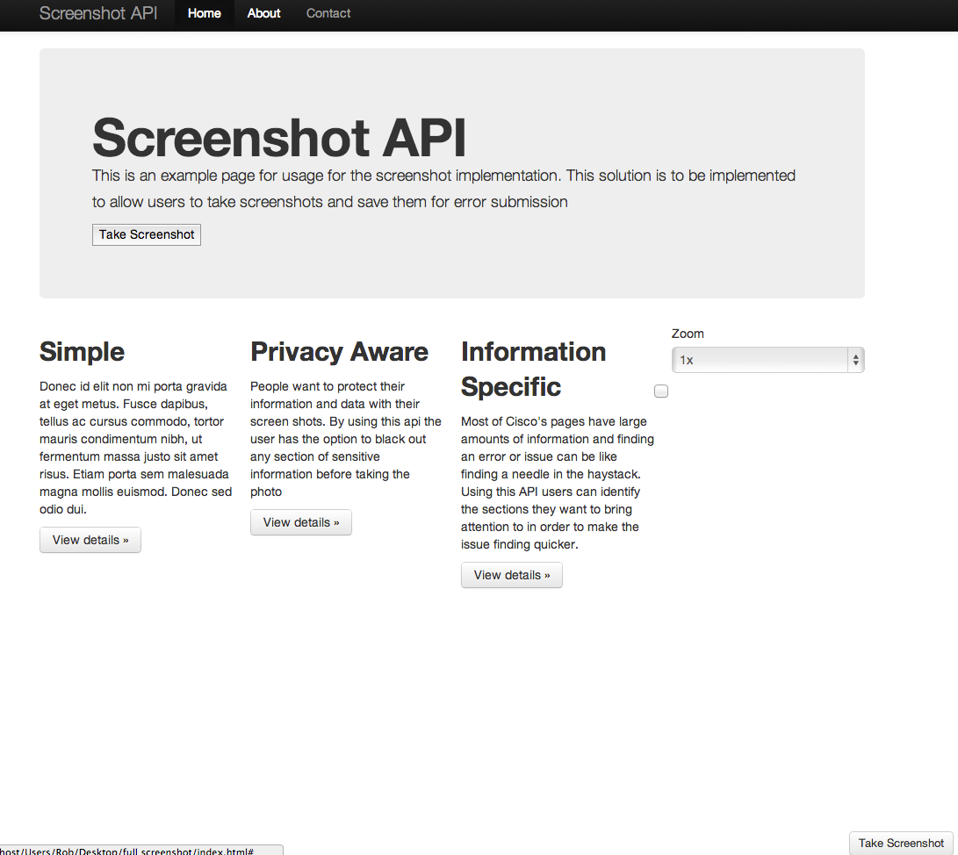

User Loads the webpage and then clicks the Screenshot button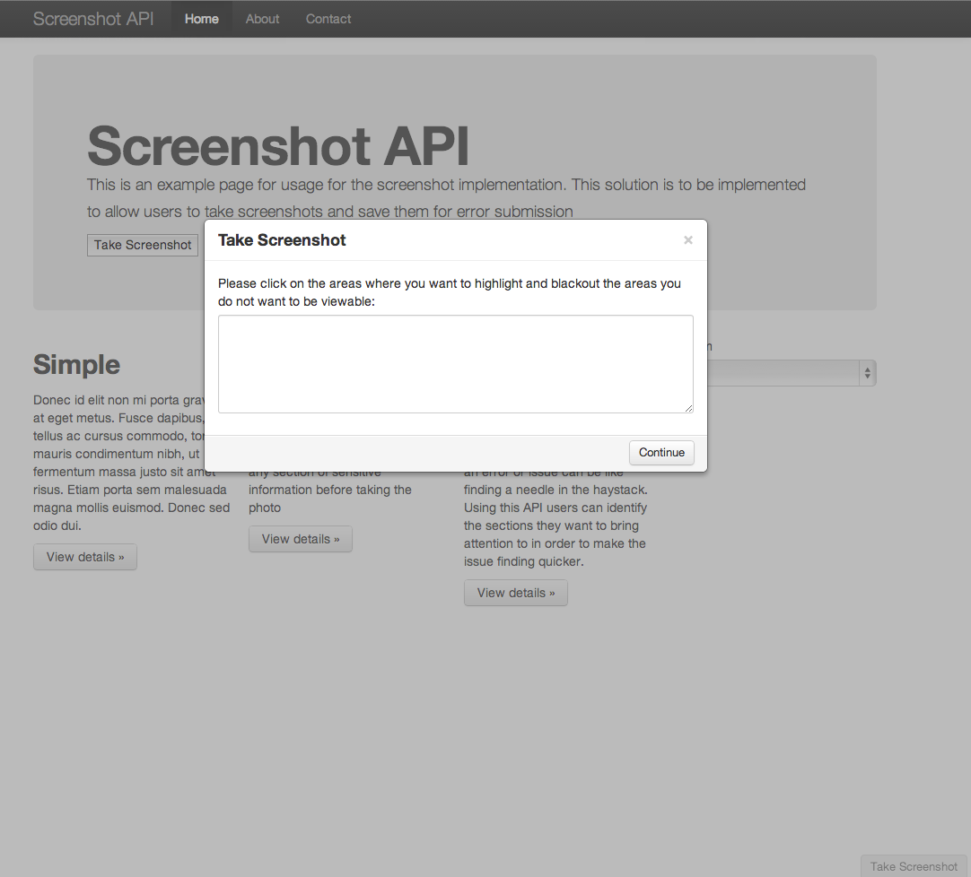

They get a prompt about some functionality of the screenshot, they click continue.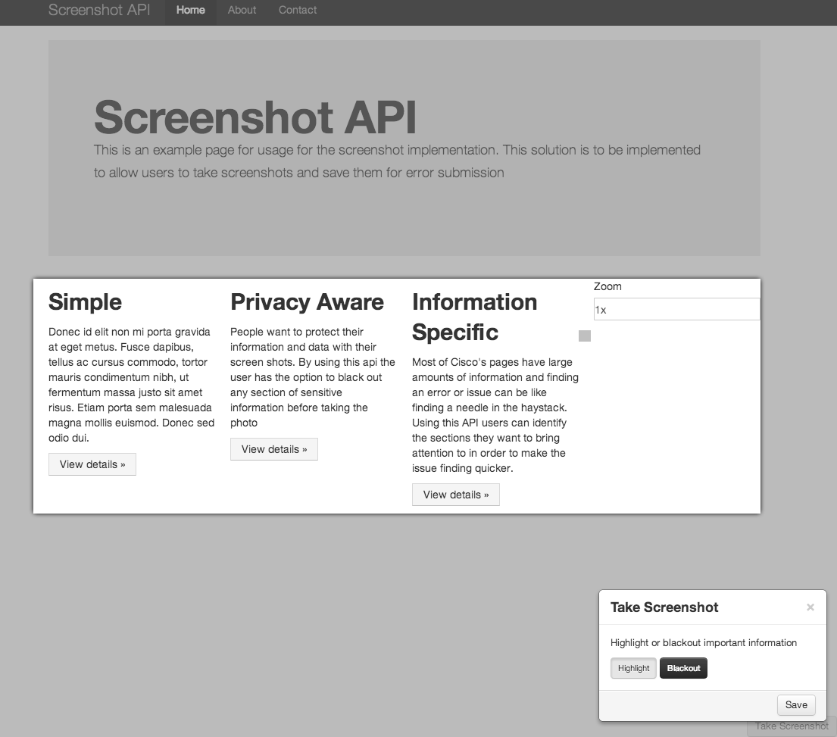

The users then define any elements that they consider important and want to highlight.

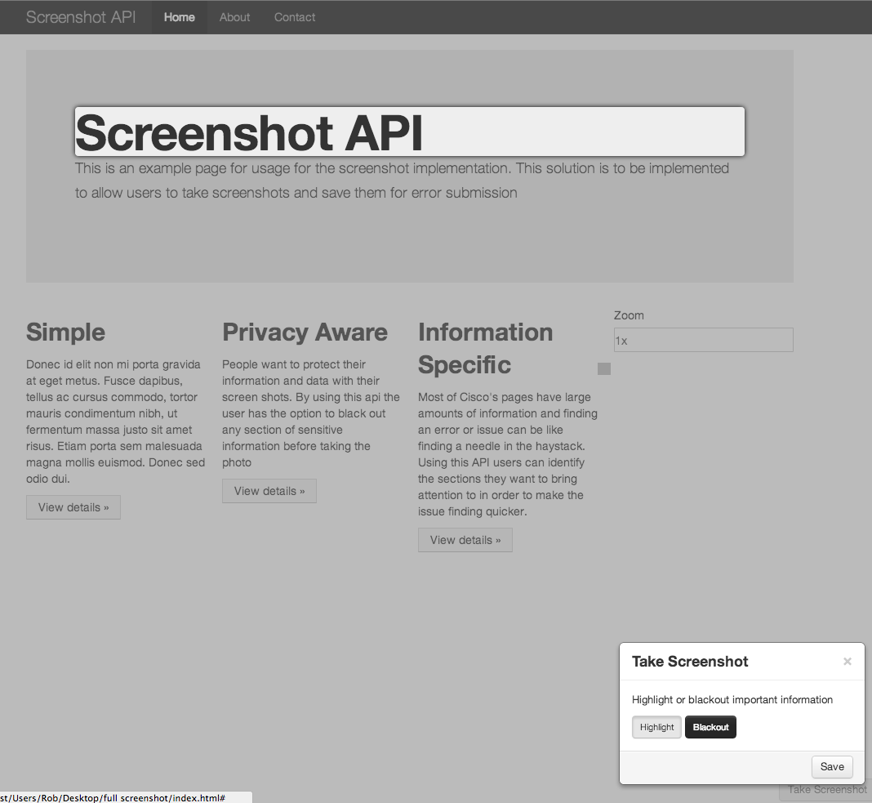

In this case my user is highlighting the title. When they are done highlighting they will click the blackout button.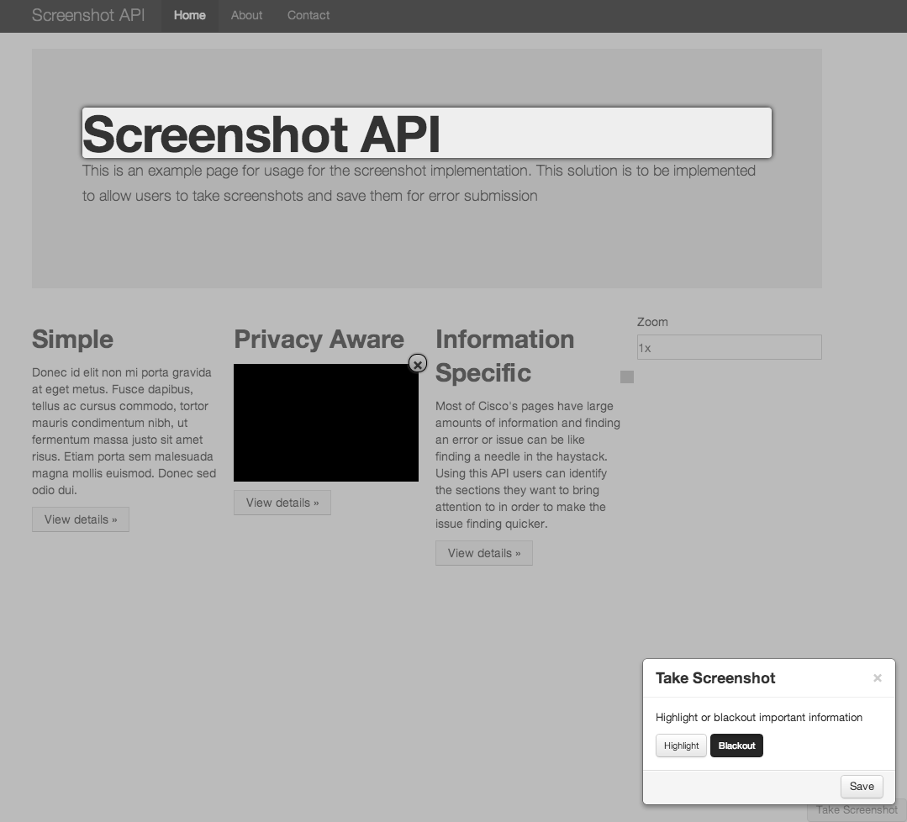

Using the blackout feature my user blacks out the information beneath the privacy aware subheading.

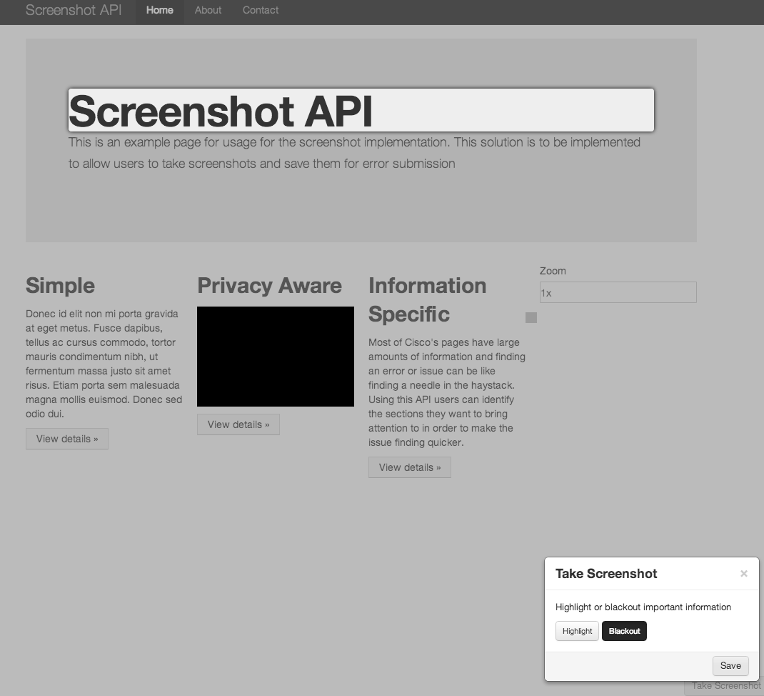

The User clicks the save button

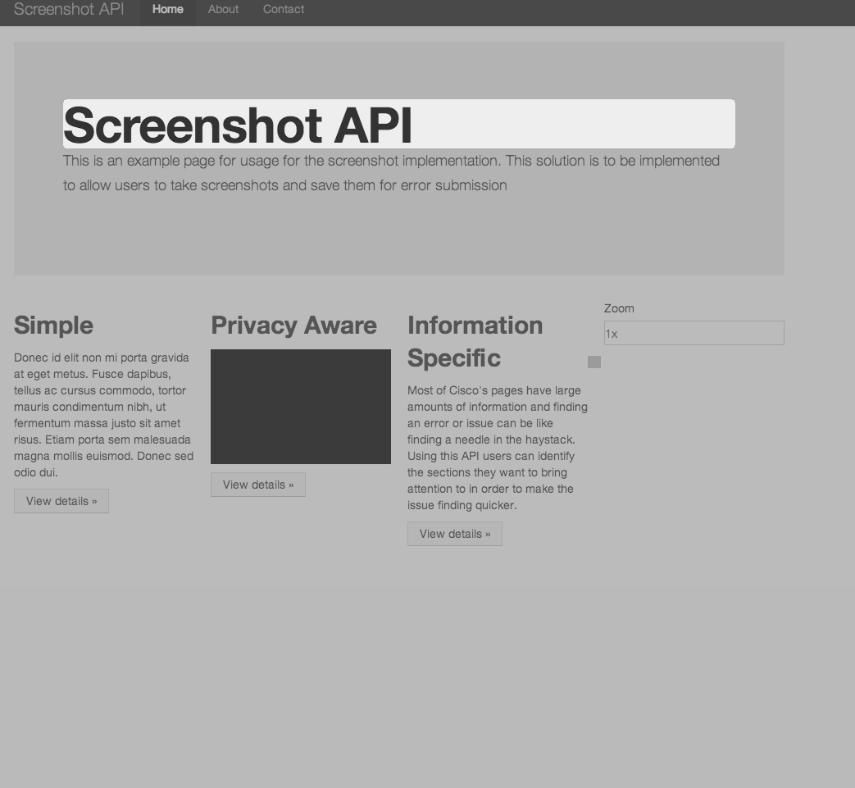

The screenshot is generated in a new tab. Notice the take screenshot button is not visible.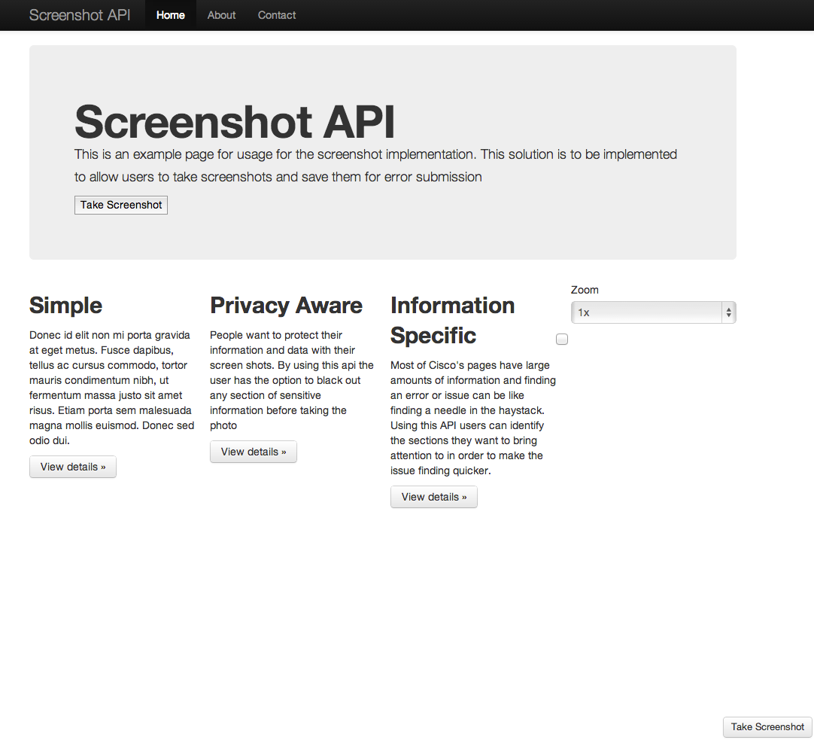

The original page has also reloaded and is done.

## Usage Development Side

To use this API we must include the Screenshot.JS file and in our JS directory along with the html2canvas and jQuery JavaScript files and then include them in our script declarations like below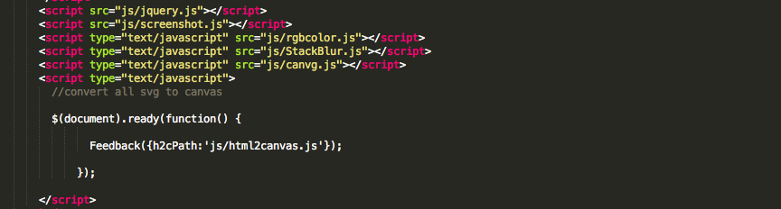

Then we must just add the three lines as present bellow and everything else is take care of by the JavaScript files. 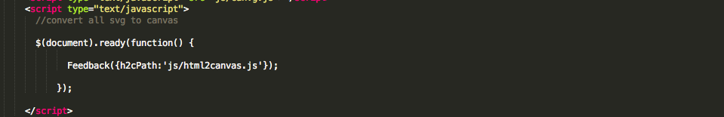

If we want some item that the user can see in their webpage but don’t want it to be in screenshots we must add a tag to the item like I have bellow with this button tag

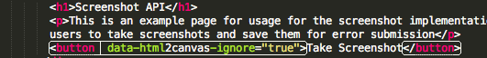

## Issues

There are a few issues in this initial alpha version of the code and they are below and plan to be worked on.

### No/Little SVG Support

Unfortunately currently websites that contain SVG elements will not be present in the Screenshots because the base API(html2canvas) does not support SVG. It was possible to convert SVG elements and add them to the website but it was lengthy, destroyed a lot of the styling and overall not a good option. The base API is currently working on getting SVG support so with a further release replacing the html2canvas library having SVG support should be enough.

### Selectable elements

Currently when taking a screenshot active intractable items(checkboxes, dropdown items, etc.) are still usable when choosing the blackout or highlight criteria. This can be an issue if the user wants to hide highlight or blackout this element but with a little finking it can be used.

## Plans

The next plans are as follow

1. Add SVG support and not just for inline SVG.
2. Turn it into a normal button and a more basic JS file.
3. Save the images on the server and integrate the API so it can be used when creating a support case.